BCM Surveyor (Your Name): _________________________________________________________________
Student Name: Year in school:
__________________________________________ __________________________________________
Major: Phone #:
__________________________________________ __________________________________________
1. What does “spirituality” mean to you? How important is it to your life on a scale from 0-10, 10 being vital to your life?
2. Do you believe in a God? Why / Why not? If so, what is this God’s character/personality?
3. Do you come from a religious background? If so, what? What makes someone religious?
4. Where do you think morality (right and wrong) comes from? Does it apply to everyone?
5. Do you think as humans it is possible to be a perfect person? Why / Why not?
6. If you believe in a God, how does this God handle the moral crimes people commit? Is there justice? Is there forgiveness? Why?
7. In your opinion, who is Jesus Christ, and why was He crucified?
8. Does God let imperfect people into a perfect heaven? Why/ Why not?
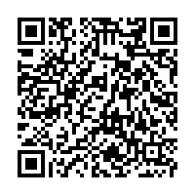
9. If you were to die tonight, how sure are you that you would spend eternity with God in heaven? (0 - 100 %)
10. Would you like to talk more about this? i.e. grab coffee or lunch sometime?

PRAYER REQUESTS? (Hand write or have them scan QR code.)
_______________________________

